Goss Binder Installation
30mm shaft with creasing outer diameter of 72.5mm
with a 6mm fixed hinge

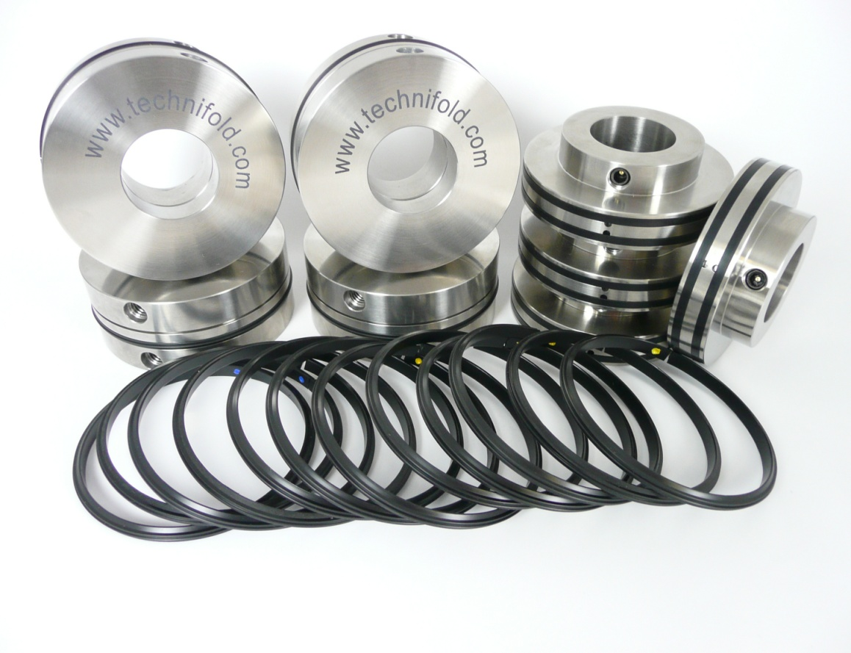

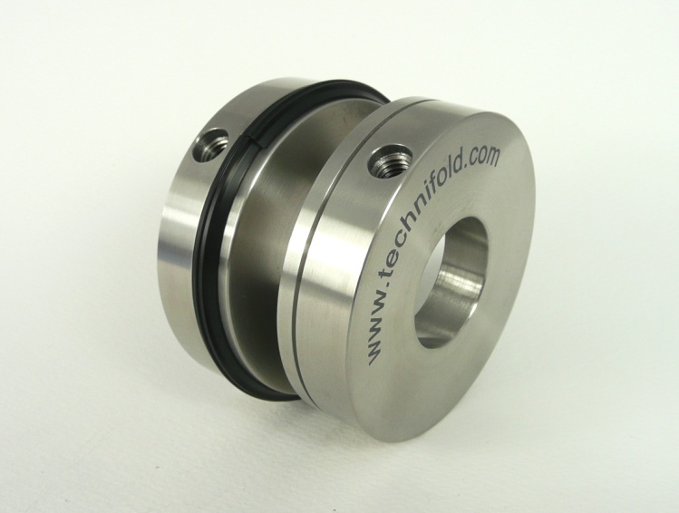
All 4 Creasing units are identical

Slide the parts apart to remove and change the crease ribs

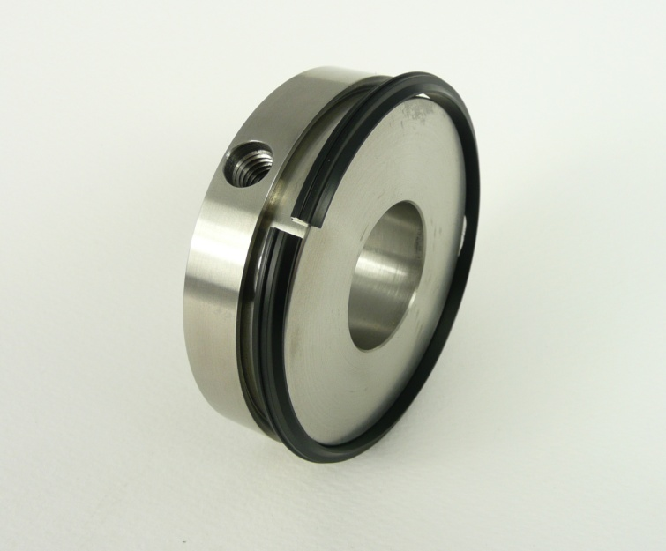
Removal of the split black nylon creasing rib
To stop crease rib damage please remove ribs from the crease units before installation on to the shafts

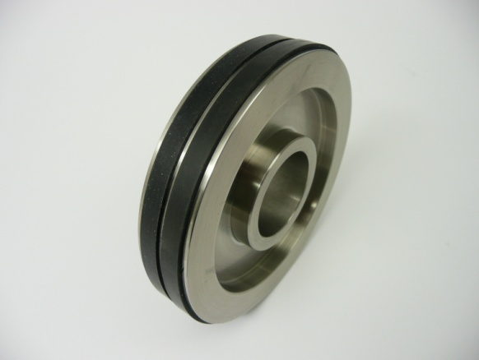
4 x Top support collars
Use the original x 4 solid metal bottom support collars and align with the new gripper support collars

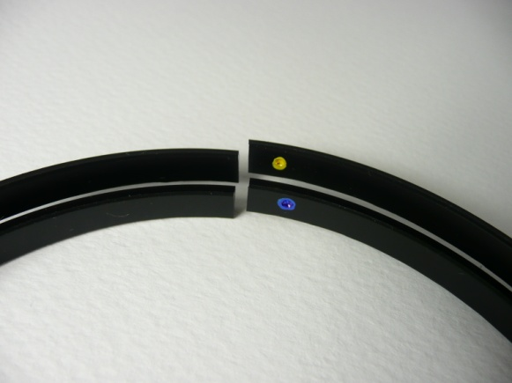

2 x depths of crease choices
Yellow dot Heavy crease
Blue dot Lighter crease

Installing the bottom shaft parts
Attach the split black nylon crease ribs that corresponds to the thickness of cover stock
Align a bottom crease unit with the edge of the book clamp and tighten fixing screw. Align the remaining bottom crease unit into the desired position and tighten the fixing screw.

Installing the top shaft parts
It is important to use the Technifold top gripper support collars & original plain metal bottom support collars.
Once the crease units are on the shaft insert the split black nylon ribs in to the units.

To achieve the correct grip between the support collars, align the collars and slowly lower the top shaft until gentle grip pressure is obtained. As the shaft is being lowered slide the top crease units so that the protrusion on the crease rib falls into the bottom female channel.
Jog a sheet of cover stock between the crease units. As the loose top crease units feed through the rotating shafts the top crease units automatically adjust to the optimum crease position. Tighten down the fixings screws when the crease unit fixing screws comes into view.
To achieve the optimum crease position the black nylon ribs must locate into the center of the female channels.
